Guardians of the Forest
  - Official Game Document
Document Type: Post-Complete Game Design Overview (Version 1.0)
Project Status: Completed, June 2022

Elevator Pitch
Guardians of the Forest is a 2D fantasy puzzle-adventure game inspired by the core mechanics of the popular Angry Birds franchise, where players fire magical projectiles from one of three unique wizards to destroy obstacles and defeat enemies, becoming a true Guardian of the Forest.

Table of Contents
Elevator Pitch 1
Table of Contents 2
Game Concept 3
Game Summary 3
Genre & Target Audience 3
Target Platform 3
Unique Selling Points 3
Story & Setting 4
Premise 4
World & Environment 4
Characters 4
Narrative Flow 7
Gameplay Overview 8
Core Mechanics 8
Objectives 8
Rules & Systems 8
Progression 9
Level Design 10
Level Layout 10
Challenges & Puzzles 10
Rewards & Progression 10
Art & Visuals 11
Art Direction 11
Characters & Environment 11
HUD & UI Elements 11
Animations 15
Audio 17
Music 17
Sound Effects 17
Controls & User Interface 18
Controls 18
UI Flow 18
Technical Specifications 19
Engine & Tools 19
Platform Requirements 19
Performance Targets 19
Development & Testing Hardware 20
Primary Development Machine 20
Quality Assurance Testing 20
Postmortem 21
Future Plans 23
References & Inspirations 24

Game Concept

Game Summary
Guardians of the Forest is a fantasy-themed, puzzle-adventure game where players select one of three wizards – each with their own unique projectile selection – to battle through eight enemy-filled levels to become a true Guardian of the Forest. The game adapts the well-known “pull-and-launch” gameplay of the popular Angry Birds franchise, but infuses it with magical spells, mystic environments, and a family-friendly setting.
The game was developed as my first full solo project with all programming, game design, audio editing, asset acquisition, and testing completed independently. The primary goal of the project was to gain hands-on experience with the full game development cycle.

Genre & Target Audience
Guardians of the Forest is a 2D single-player, puzzle-adventure game aimed at a wide and casual audience. Players who enjoy physics-based puzzles experiences, magical fantasy themes, or any title from the Angry Birds franchise will be sure to enjoy what’s in store.
Recommended age: PEGI 3 – Mild violence.

Target Platform
The game targets Windows PC exclusively. Limited experience with mobile and console development defined a scope centred on the Unity PC build pipeline.

Unique Selling Points
- Unique Take on a Classic Formula: Mixes the classic Angry Birds formula with a magical, fantasy twist.
- Interesting Replayability: With three unique wizards who each own two unique projectiles; there is plenty of replayability within the game.
- Unlimited Target Audience: The game is suitable for almost all ages with family-friendly visuals, gameplay, and themes.
- Short But Sweet: The small nature of the game ensures play sessions are satisfyingly short but sweet for players.

Story & Setting

Premise
The mystical forest of the Guardians has been seized by evil skeletons, goblins, and golems. As one of the three Guardian Wizards – each with their own unique magical projectiles – you must push through enemy-occupied forest regions and reclaim the land, becoming a true Guardian of the Forest in the process.

World & Environment
The game takes place across various mystical forest environments, each themed to match the encountered enemies. The tone is light, colourful, and accessible, blending whimsical fantasy with mild elements of danger.
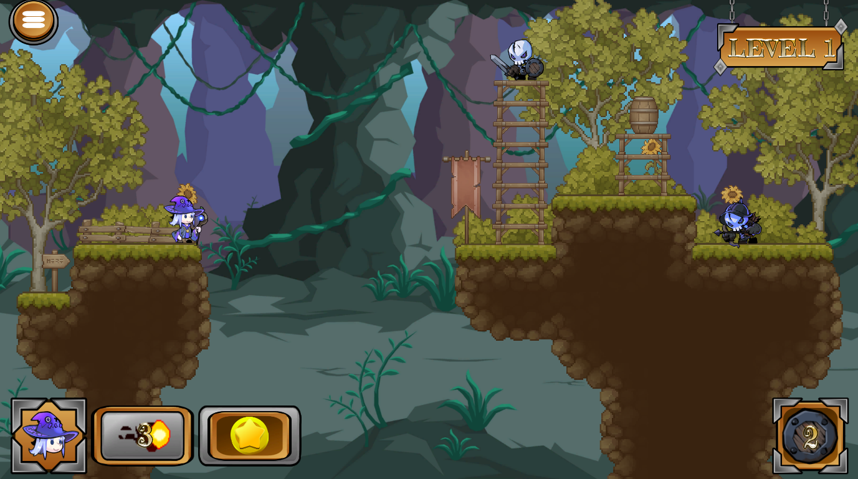
Figure 1: The world environment of Guardians of the Forest.

Characters
Guardian Wizards (Protagonists)
Elemental Wizard
Bio: Focuses on bending Earthen elements to their will to destroy their enemies.
Projectiles: Fireball, Electricball
Playstyle: High-impact, destructive spell casting with visually explosive power.
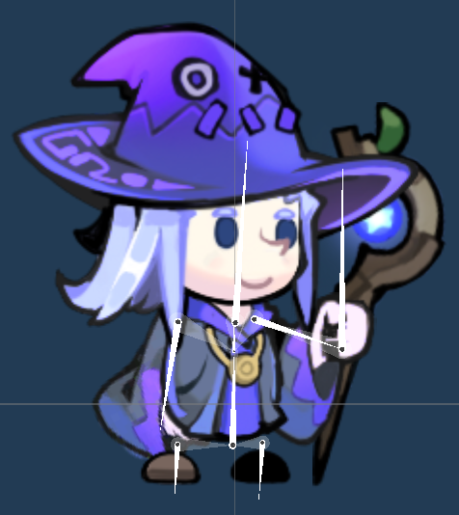
Figure 2: The Elemental Wizard.
Healer Wizard
Bio: Focuses on their medicinal skills to defeat enemies standing in their way.
Projectiles: Bloodball, Poisonball
Playstyle: Pre-planned, delayed interactional spell casting with devasting influence.
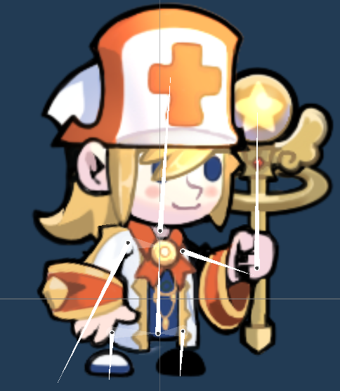
Figure 3: The Healer Wizard.
Monk Wizard
Bio: Focuses on ancient, unhinged magic to perform heroic dark arts to overcome their enemies.
Projectiles: Cosmicball, Voodooball
Playstyle: Strong, mystical spell casting with tide-turning capabilities.
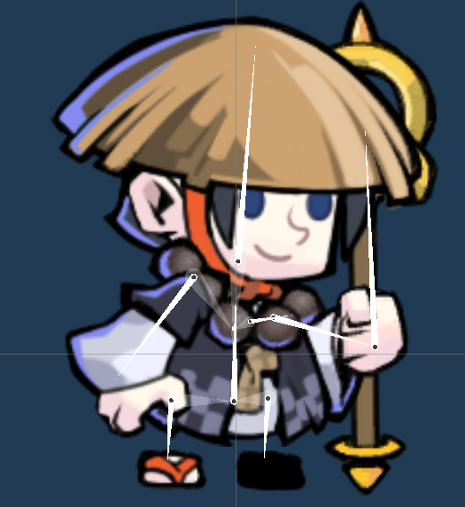
Figure 4: The Monk Wizard.

Enemies (Antagonists)
The forest is defended by three different enemies: Skeletons, Goblins, and Golems, each with three visual variants. The enemies do not move, attack, or perform actions of any sort – they simply serve as destructible targets like many obstacles in the game. However, these are the main target for players to destroy in order to progress.
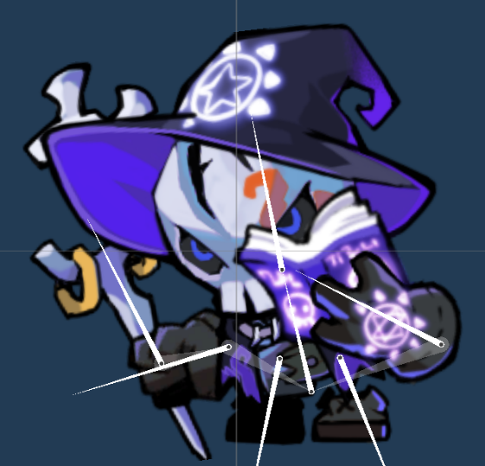
Figure 5: The Wizard Skeleton, one of three Skeleton variants.
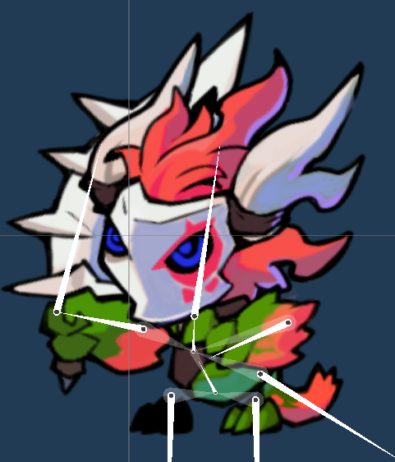
Figure 6: The Berserker Goblin, one of three Goblin variants.
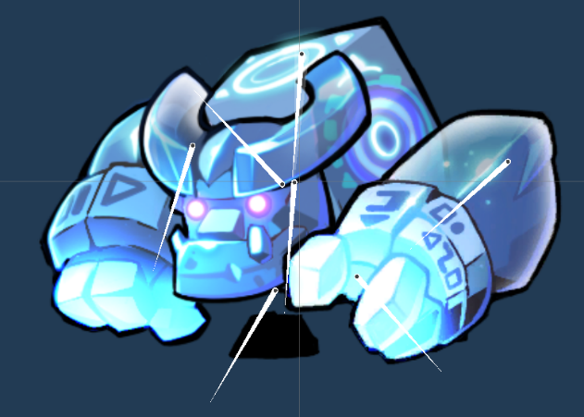
Figure 7: The Ice Golem, one of three Golem variants.

Narrative Flow
The story is narratively delivered subtly through level progression, with each advancing level representing a deeper section of the forest where enemy numbers gradually increase. Upon completion of the final eighth level, players are rewarded with an in-game certificate officially recognizing them as a Guardian of the Forest.

Gameplay Overview

Core Mechanics
Players click and drag their chosen wizard to aim their projectile shot before releasing the mouse button to fire away at the environment. The controls are:
- Movement & Aiming: To move the wizard and aim the projectile.
- Fire: To fire the projectile.
- Projectile Power-Up: To activate the chosen projectile’s Power-Up.

Objectives
The one and only objective is to defeat all eight levels of the game. To do so, players must defeat all enemies within the level to advance. To defeat an enemy, players must either hit them directly with their projectile or knock an obstacle onto the enemy’s head.

Rules & Systems
Players are limited to three projectiles for the first six levels, and then five projectiles for the final two levels to count for the extra added enemies. Each projectile has its own unique Power-Up that can be activated once per level to aid players in their objective. If players do not defeat all enemies once all their projectiles have been used, they must restart the level.
Projectile | Projectile Behaviour | Power-Up Name | Power-Up Ability
Bloodball | ‘Bloodies’ all objects it touches for its Power-Up combo with average size and speed | Bloodburst | Bursts all bloodied objects at once, sending them flying in random directions
Cosmicball | Super-fast projectile with small size | Cosmic Energy | Enlargers the Comsicball’s size while retaining its super speed
Electricball | Zaps all objects it touches with its big size making up for its slow speed | Zap-Tastic! | Triples the zapping power when electrocuting objects
Fireball | Burns through all objects it touches with high speed | Laser-Beam of Fire | Fires a deadly laser-beam vertically, destroying everything in its path
Poisonball | ‘Poisons’ all objects it touches for its Power-Up combo with average size and speed | Poison Smoke | Destroys all poisoned objects at once
Voodooball | ‘Curses’ all objects it touches for its Power-Up combo with average size and speed | Way of the Voodoo | Destroys all cursed objects at once with a big explosion and randomly auto-kills a remaining alive enemy

Progression
Players enter deeper into the forest to continue their mission of clearing all enemies the further they advance for gameplay story progression. Additionally, the final two levels of the game feature a higher enemy count, rewarding players with an additional two projectiles to fire.

Level Design

Level Layout
Each level features a standing platform for the player wizard to stand and move on towards the left-hand side of the screen, while the right-hand side is filled with varied platform designs to hold enemies and obstacles. The environmental structures, enemies, and enemy count vary between levels, while every two levels feature its own unique background and style to represent a different region of the forest.
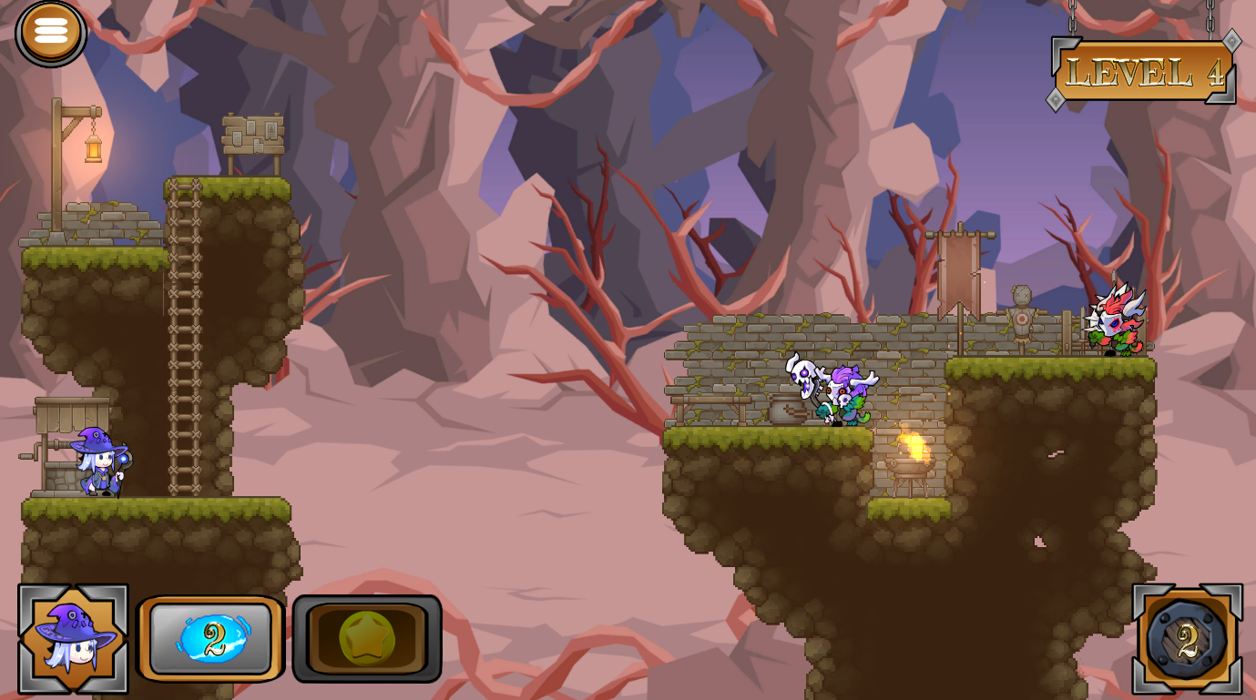
Figure 8: The level design of Level 4, featuring the player wizard movement platform to the left and the remainder of the level with obstacles and enemies to the right.

Challenges & Puzzles
While the core challenge of the game is physics, the game’s level design carefully positions platforms, obstacles, and enemies to encourage strategic projectile choice and aim, as well as smart Power-Up usage. Some projectiles excel in tight spaces, others in destruction, and others in open angles.

Rewards & Progression
The further players advance, the more visual storytelling they discover, as well as an additional two extra projectiles for the final two levels. Upon completion of the game, players are rewarded with a certificate congratulating them on becoming a true Guardian of the Forest.

Art & Visuals

Art Direction
The art direction is a stylized, colourful, cartoon aesthetic which complements the magical and family-friendly theme of the game. This decision allows for approachable visuals that brings the whimsical world to life.

Characters & Environment
Levels feature unique colours and atmospheres tailored to each specific forest region. All three wizards and enemies are from the same asset designer to easily merge them into the world, with unique designs to showcase their personality traits. The environmental background objects and obstacles further enhance the magical forest by seamlessly fitting into the created world with visuals to match.

HUD & UI Elements
The HUD features elements at the top and bottom of the screen to help players with their gameplay. The elements are appropriately sized to ensure gameplay is not affected negatively.
- Pause/Menu Button (Top-Left): Pauses the game, displaying the Pause Menu.
- Level (Top-Right): Showcases the current level the player is on.
- Selected Wizard (Bottom-Far Left): Displays the player’s selected wizard.
- Selected Projectile (Bottom-Middle Left): Displays the player's selected projectile.
- Power-Up Activation Status (Bottom-Close Left): Showcases the projectile’s Power-Up activation status. The Power-Up is still available to use if this icon is not greyed out.
- Remaining Enemies (Bottom-Right): Shows the remaining enemies alive in the level.
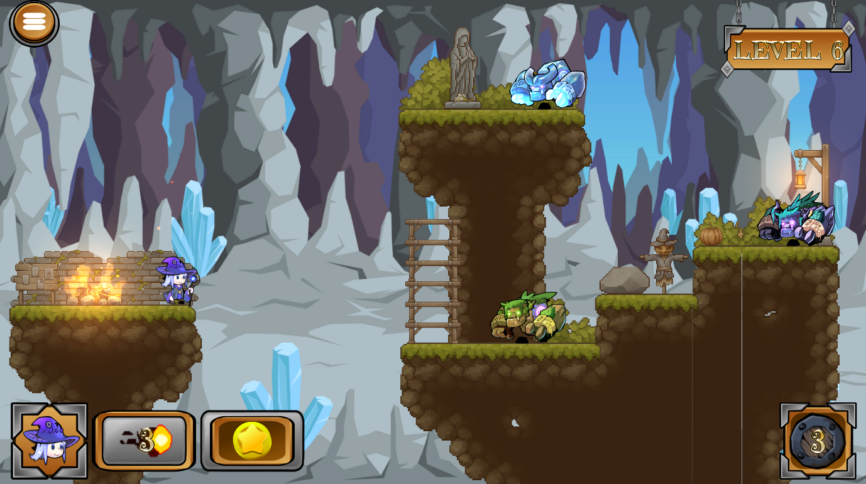
Figure 9: The HUD.
The Main Menu is displayed on a hanging canvas in front of a region of the forest, displaying a variety of elements.
- Start Button: For starting a new game.
- Continue Button: For continuing from a saved game.
- Options Button: For viewing and selecting the wizard and projectile options.
- Credits Button: For viewing the credits of the game.
- Quit Button: For quitting the game.
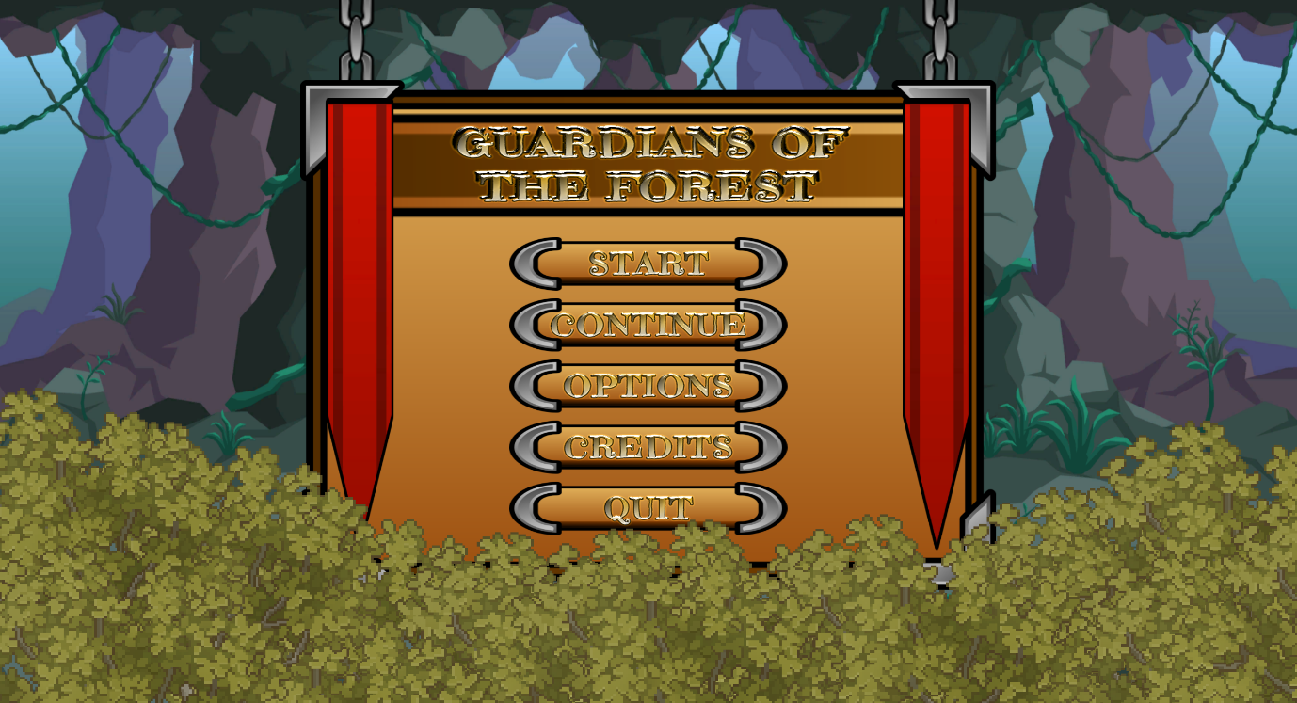
Figure 10: The Main Menu.
The Pause Menu utilizes the same hanging canvas design as the Main Menu, just smaller to partially take up space on the gameplay screen.
- Resume Button: Resumes the game.
- Options Button: Same function as the Main Menu, minus the ability to select a new wizard and/or projectile.
- Quit Button: Quits to the Main Menu.
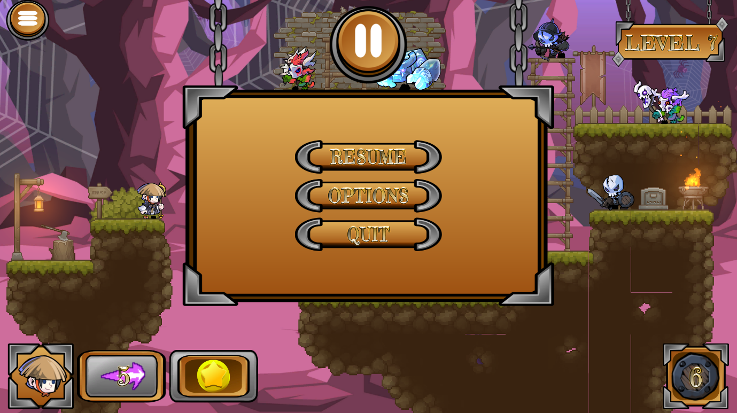
Figure 11: The Pause Menu.
The Level Failed Menu is similar in design to the Pause Menu, featuring different elements.
- Continue Button: Restarts the failed level.
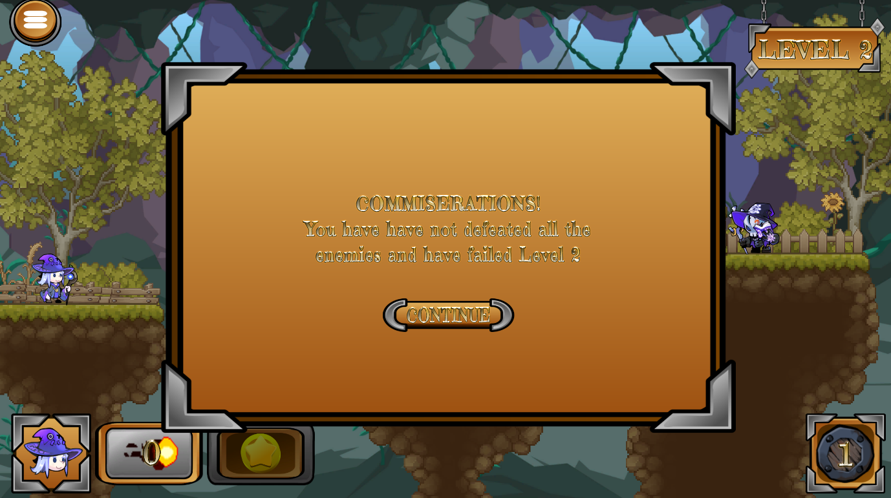
Figure 12: The Level Failed Menu.
The Level Completed Menu is the same as the Level Failed Menu, with its own elements.
- Continue Button: Starts the next level.
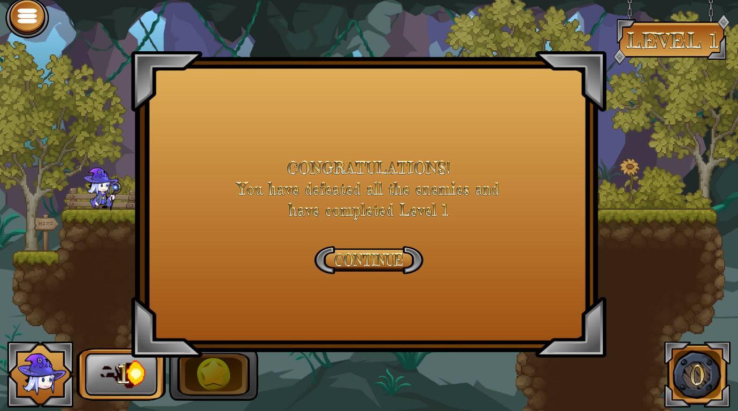
Figure 13: The Level Completed Menu.
The Game Completed Menu also uses the same design as both the Level Failed and Level Completed Menus, containing its own elements.
- Menu Button: Returns to the Main Menu.
- Quit Button: Quits the game.
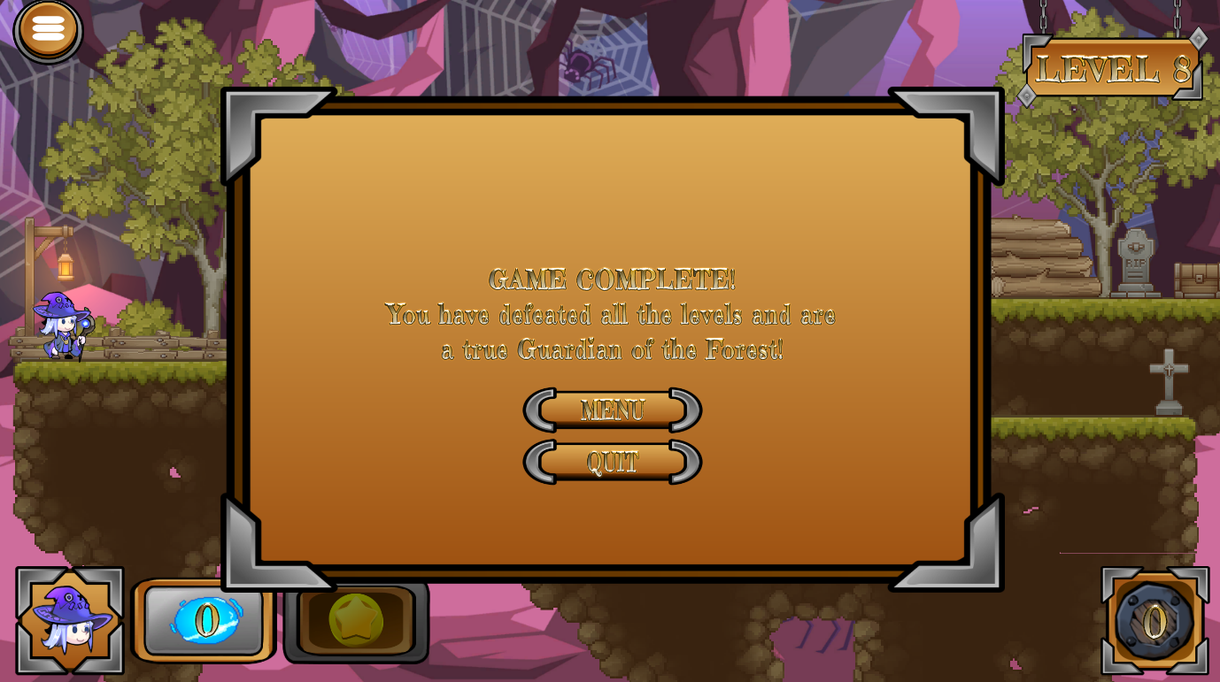
Figure 14: The Game Completed Menu.
The HUD and menus utilize the same one font which was carefully selected to match the theme of the game while also being accessible for all to read with ease.

Animations
Player
Each Guardian Wizard has animations for idling and firing projectiles, each suited to their own personalities to ensure each not only has its own look and gameplay designs, but also its own identity through lifelike movements. Additionally, upon completion of a level, each wizard has its own victory celebration animation.
Projectiles
All six projectiles have their own animations for movement, collision, and Power-Up activation. Each of these animations were carefully selected to bring each projectile to life with their own unique identities, acting as main characters themselves. For example, the Fireball uses a laser-beam of fire animation for its Power-Up, while the Poisonball uses a big poison smoke poof for its Power-Up animation, distinctively separating each projectile.
Some projectile Power-Up animations, such as the Fireball and Voodooball, feature multiple visual effects merged into one for a grand design. Although the visuals were sourced from a designer, these specific multi-merge animations were created my myself.
Enemies
All three enemies have their own idling animations shared across their variants. All three enemies share the same death animations due to the functionality being shared and not requiring specific unique animations.
Environment
The environment is full of animated background objects and obstacles, such as fragile wooden planks, boxes, chests, campfires, and more. These help bring the world and the game to life with a ‘real feel’, further helping to enhance the magical effect of the game.
UI
All menus use a handcrafted animation which sees the hanging canvas drop down from the top of the screen on chains to add more magic and personality to the overall feel of the game.

Audio

Music
Guardians of the Forest is an upbeat, casual, fantasy themed game, and therefore uses catchy soundtracks for each individual level and menu. Each level progressively gets harder as the player nears the more dangerous regions of the forest, which is not only shown by the scenery and enemy count, but also through the soundtracks which progressively get more intense.
The menus ensure players feel comfortable and relaxed with charming fantasy-themed music appropriate for menu navigation.

Sound Effects
There are a handful of sound effects featured in Guardians of the Forest to further help bring the magical world to life. The wizards all share the same firing sound when a projectile is fired, and each enemy type uses its own idling sound to audibly show they are alive – until defeated, where a distinct death sound and poof sound are played one after another.
All six projectiles have their own unique sounds for movement, collision, and Power-Up activation to provide important audio cues for players. All UI elements utilize appropriate button click sounds for when buttons are clicked.
These sound effects help glue the game together with a polished design to ensure players feel as immersed as possible within the experience.

Controls & User Interface

Controls
Movement & Aiming (Left-Mouse Click)
Allows the player to move their character and aim the projectile.
Fire (Left-Mouse Unclick)
Allows the player to fire their projectile.
Projectile Power-Up (Enter)
Allows the player to activate their projectile’s Power-Up.
A key rebinding system is not implemented due to the casual, easy-to-play nature of the game and controls.

UI Flow
The HUD can feature a handful of elements at any given time, but they are all strategically sized and placed to avoid interruption with gameplay. To ensure consistency across all HUD, menus, and other UI elements, the same ‘hanging canvas’ design is used. All menus support full mouse navigation for ease-of-use.

Technical Specifications

Engine & Tools
Guardians of the Forest was developed with Unity and C# for core systems. Visual Studio 2022 (coding) and Audacity (audio) was used for other purposes.

Platform Requirements
Minimum Requirements:
- OS: Windows 10 64-bit
- Processor: Intel Core i5-4th Gen or equivalent
- Memory: 4 GB RAM
- Graphics: NVIDIA GeForce GTX 750 Ti / AMD Radeon R7 260X
- VRAM: 1 GB
- Storage: 200 MB available space
- DirectX: Version 11
Recommended Requirements:
- OS: Windows 10/11 64-bit
- Processor: Intel Core i7-9th Gen or equivalent
- Memory: 8 GB RAM
- Graphics: NVIDIA GeForce GTX 1060 / AMD Radeon RX 580
- VRAM: 3 GB
- Storage: 500 MB available space
- DirectX: Version 12

Performance Targets
- Frame Rate: 60 FPS locked
- Resolution: 1920x1080, adapts to player’s display resolution
- Loading Times: ~1-2 seconds on SSD; ~5-10 seconds on HDD

Development & Testing Hardware

Primary Development Machine
- OS: Windows 10 64-bit
- Processor: Intel Core i7-9750H
- Memory: 16 GB RAM
- Graphics: NVIDIA GeForce RTX 2080 Super Max-Q
- VRAM: 8 GB
- DirectX: Version 12

Quality Assurance Testing
The game was tested on the primary development machine only due to the purpose of the game being to create a small scope starter project for my learning. I, amongst a few close others, helped test the functionality, performance, and overall fun-factor to ensure the best experience was created.

Postmortem
What Went Well
- Many skills from learning the Unity game engine to programming practices not only with the C# language but also with general practices that can be used across various other languages were successfully learned throughout the project’s creation, which was one of the goals of the project.
- The game works as intended with smooth, enjoyable gameplay and a unique, fantasy theme bringing the entire project together.
- If the project was to be revisited for additional work, a solid foundation has been created to allow this.
What Could Have Been Better
- The project began with minimal pre-production planning, with only the idea of the game being established without any proper plan to implement the project. Much of the project was made reactively rather than intentionally, which didn’t affect the production much due to the game’s small scope, but could have affected it more if the game was larger.
- The game was tested only on the primary development machine and by a small group of people, meaning the breadth of user testing was limited which therefore limited the amount of feedback received.
- The use of version control with Git was at times minimal and inconsistent due to the project being a first solo development, where knowledge of version control was limited. Taking the time to learn more about this pre-production would have resulted in better version control management – which is crucial to a game’s development cycle.
- Some features took a while to implement due to lack of experience. Better scheduling would have helped keep development momentum while managing expectations.
Key Lessons Learned
- The importance of the pre-production phase of development is not to be underestimated. Creating documentation, prototypes, technical plans, and learning necessary systems beforehand dramatically improves efficiency, clarity, and reduces redesign work later.
- Building small and functional systems then iterating on them proved far more effective than building large interconnected systems all at once.
- Tracking workload and setting realistic goals keeps the project’s scope small and achievable.
- Completing a game solo – from programming to audio manipulation to asset acquisition – provided hands-on experience across the entire development pipeline.

Future Plans
Guardians of the Forest is a standalone experience with no plans for any downloadable content or future sequels. However, the game could easily be expanded upon due to the solid framework created, where a variety of new levels, wizards, projectiles, and enemies could be implemented if any thoughts of a return were to occur.

References & Inspirations
Games
The main inspiration for Guardians of the Forest is, of course, the Angry Birds franchise. The game uses the same mechanics and gameplay themes as Angry Birds, just with its own twist on setting, story, characters, and some minor mechanical changes.
Other
Fantasy and magic themes are heavily present throughout the game. These ideas were chosen as they are widely regarded as family-friendly and help bring imagination to life in fun and creative ways with minimal restrictions.

